**Password Based Door Lock System using 8051 Microcontroller**

Traditional lock systems using mechanical lock and key mechanism are being replaced by new advanced techniques of locking system. These techniques are an integration of mechanical and electronic devices and highly intelligent. One of the prominent features of these innovative lock systems is their simplicity and high efficiency.  Such an automatic lock system consists of electronic control assembly which controls the output load through a password. This output load can be a motor or a lamp or any other mechanical/electrical load. Here we develop an electronic code lock system using 8051 microcontroller, which provides control to the actuating the load. It is a simple embedded system with input from the keyboard and the output being actuated accordingly. This system demonstrates a password based door lock system wherein once the correct code or password is entered, the door is opened and the concerned person is allowed access to the secured area. Again if another person arrives it will ask to enter the password. If the password is wrong then door would remain closed, denying the access to the person.

**Also read the related post:** [**Electronic Code Lock System using Single Transistor**](http://www.electronicshub.org/one-transistor-electronic-code-lock-system/)

**Principle Behind the Circuit:**

The main component in the circuit is 8051 controller. In this project 4×3 keypad is used to enter the password. The password which is entered is compared with the predefined password. If the entered password is correct then the system opens the door by rotating door motor and displays the status of door on LCD. If the password is wrong then door is remain closed and displays “pwd is wrong” on LCD.

**Circuit Diagram of Password Based Door Lock System using 8051 Microcontroller:**

[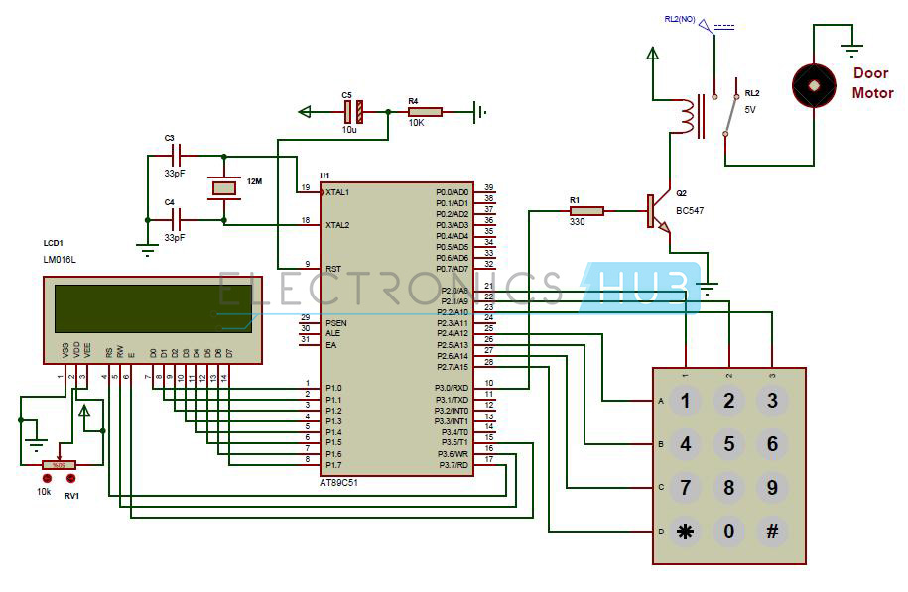](http://www.electronicshub.org/wp-content/uploads/2014/08/Password-Based-Door-Locking-System-Circuit-Diagram-using-8051.jpg)

**Password Based Door Locking System Circuit Diagram using 8051**

**Password Based Door Locking System Project Required Components:**

**Hardware Requirements:**

* at89c51 controller
* 8051 programming board
* Programming cable
* DC battery or 12V,1A adaptor
* 4×3 matrix keypad
* 16×2 LCD
* 5V Relay
* DC motor
* BC 547 Transistor
* 10k, 330 Ω  resistor (1/4 watt)
* 10uF electrolytic capacitor
* 33pF capacitors – 2
* 12MHz Crystal
* Pot 10k (1/4 watt) – 1
* connecting wires

**Software Requirements:**

* Keil compiler
* Flash magic
* Proteus

**Electronic Code Lock System Circuit Design:**

Password based door lock circuit design uses five major components – a Microcontroller, a Relay, a DC motor, a 4×3 matrix keypad and a LCD. Here AT89C51 microcontroller is used and it is an 8-bit controller. This controller requires a supply voltage of +5V DC. In order to provide regulated 5V DC voltage to the controller we need to use 7805 power supply circuit. We can use 9V DC battery or 12V, 1A adaptor as a power source.

**Reset Circuit Design:**The reset pin of the microcontroller is kept active till the power supply is in the specified range and a minimum oscillation level is maintained.  In other words to ensure the supply voltage does not falls below the threshold level of 1.2V and the reset pulse width is greater than 100ms (recommended for 89C51),  we select the values of resistor and capacitor such that RC >=100ms.  Here we select a 10K resistor and a 10uF electrolyte capacitor.

**Oscillator Circuit Design:** A crystal oscillator is used to provide external clock signal to the microcontroller. To ensure smooth operation, we connect two ceramic capacitors ranges from 20pF to 40pF. This crystal oscillator is connected between pin 18 and 19 of the microcontroller.

**Compilation of Microcontroller Code:**Once the circuit is designed and drawn on a piece of paper, the next step is to write and compile the code. Here we select the Kiel uVision software to write the program in C language.

Prior to writing the code, general steps needs to be followed like creating a new project and selecting the target device or the required microcontroller. Once the code is written, we saved it with .c extension and then added it to the source file group under the target folder.  The code is then compiled by pressing F7 key.

Once the code is compiled, a hex file is created.  In the next step, we use Proteus software to draw the circuit. The code is dumped into the microcontroller by right clicking on the IC and then adding the hex file.

**Related Post:** [**Password Based Circuit Breaker Project Circuit Diagram and Working**](http://www.electronicshub.org/password-based-circuit-breaker/)**.**

**Password Based Door Lock System Circuit Simulation Video:**

Before going to read the working of this circuit, Watch the following simulation video to get clear idea about how the above circuit works.

**Password Based Door Locking System Circuit Operation:**

Once the circuit is powered, microcontroller sends commands to the LCD to display “enter password” on LCD.  Now we need to enter the password using the keypad. Once password is entered, it displays 5 stars on LCD to indicate that controller read password successfully.  Now the controller compares the entered password with predefined password. If the password is matched then controller makes P3.0 high. So the base of the transistor gets sufficient current to drive the relay, as a result Door motor rotates to open the door. If the password is not matched then microcontroller makes P3.0 low. Hence door motor is at stationary so that door remains close.

**Note:** while giving the connections, make sure that there is no common connection between AC and DC supplies.

**Password Based Door Lock System Algorithm:**

1. Initially declare the PORT1 to LCD data pins and control pins to P3.5, P3.6 and P3.7 and declare PORT2 to keypad. And use P3.0 to Door motor.
2. Initially display enter password on LCD.
3. Now read the five digit password from the user, while reading each digit from the keypad display * symbol on LCD.
4. Compare the entered password with stored password.
5. If password is correct then make P3.0 pin high for some time to open the door. After that display *“Door is opened”* on LCD.
6. If the password is wrong then display *“pwd is wrong”* on LCD.
7. After some delay again ask to enter password.

**Advantages of Password Based Door Lock System:**

* This project provides security
* Power consumption is less
* Used commonly available components
* Project is simple and easy

**Applications of Password Based Door Lock System Circuit:**

* This simple circuit can be used at residential places to ensure better safety.
* It can be used at organizations to ensure authorized access to highly secured places.
* With a slight modification this Project can be used to control the switching of loads through password.

**Limitations of Password Based Door Lock System:**

* It is a low range circuit, i.e. it is not possible to operate the circuit remotely.
* If you forget the password it is not possible to open the door.